DEALS TO IRVING, TX

Irving is centrally located between Dallas and Fort Worth. As home to the Dallas Cowboys and Texas Rangers, two of the biggest sports teams in the area, it’s a busy place for sports fans. Book a trip to Irving via Dallas Love Field on Virgin America. Live it up at 35,000 feet with WiFi, on-demand entertainment, and more on every flight.

(MARKET IMAGE HERE)

Find Deals From These Cities

INSERT FARE GRID FROM / TO Version (if available!)



Top Things To Do in Irving, TX

Check out a few of our favorite activities in Irving, TX below.

* Take a gondola ride along the Mandalay Canal. Old World style gives this section of the city a distinct look from the rest of modern Irving.
* Stroll through Williams Square and admire the Mustangs of Las Colinas, the largest equestrian sculpture in the world.
* Visit the Irving Arts Center to tour its sculpture garden and see one of the many performances or art exhibits held throughout the year.
* Stroll along Campion Trails, a 22-mile greenway following the Trinity River. Keep an eye out for the native wildlife, and passing horses!

Travel Tips and Resources

[Must-Dos in Irving](https://www.virtualtourist.com/travel/North_America/United_States_of_America/Texas/Irving-878400/Things_To_Do-Irving-TG-C-1.html)

[Irving Hotels](http://www.tripadvisor.com/Hotels-g56032-Irving_Texas-Hotels.html)

[Irving Restaurants](http://www.tripadvisor.com/Restaurants-g56032-Irving_Texas.html)

[Irving Shopping Guidehttp://www.irvingtexas.com/things-to-do/shopping](http://www.irvingtexas.com/things-to-do/shopping)

[Irving Nightlife and Entertainmenthttp://www.irvingtexas.com/things-to-do/nightlife](http://www.irvingtexas.com/things-to-do/nightlife)

[Irving Travel Tips](http://www.tripadvisor.com/Tourism-g56032-Irving_Texas-Vacations.html)

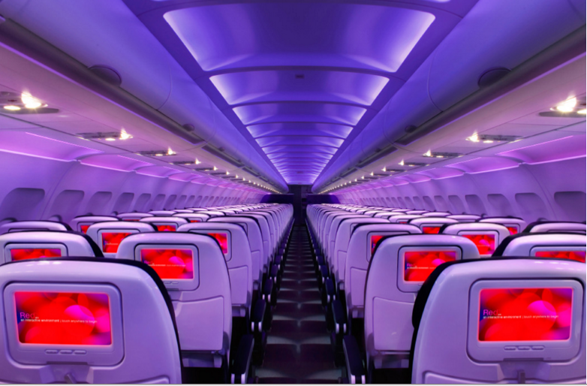

Main Cabin Main Cabin Select First Class

(add links to Cabin Class Pages)

Ready. Set. Fly.

Book your Mood-lit Ride to Irving, TX.

When planning and researching flights to Irving, you’ll see that Irving is served by Dallas Love Field (DAL). Book your flight to Texas with Virgin America and enjoy numerous amenities that make your flight a wonderful experience. Spacious seats with personal outlets, on demand food ordering, mood-lit cabins and on-demand WiFi are just a few of the things that make Virgin America special.

Take a Virtual Tour

Add Terms & Conditions